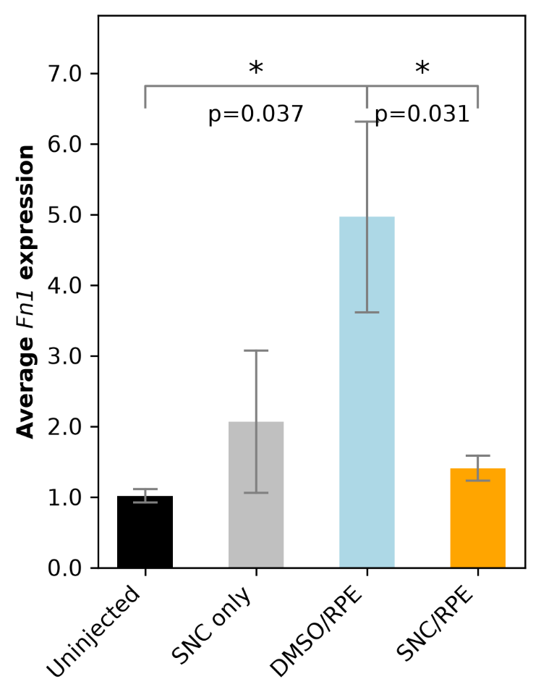
Figure 1. Relative Fn1 expression across treatment groups.
Fn1 mRNA levels were measured by RT-qPCR, normalized to Gapdh, and expressed relative to Uninjected controls. Each sample is the average of four technical replicates. Data are means ± SEM (n = 4 for Uninjected and SNC only; n = 5 for DMSO/RPE and SNC/RPE). Two-tailed unpaired t-test; * p < 0.05.

